Midterm Lab Task Set 1
Python Basic Input-Output/Operators/Escape sequence
and Placeholders
Problem 1. Using print statement
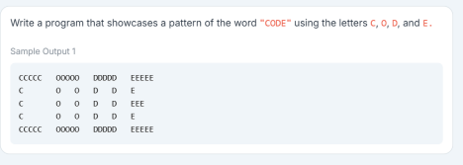
Problem 2. Using Escape Sequence. Use only 1 print statement for this output
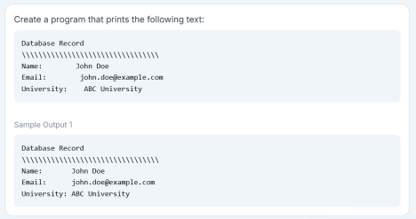
Problem 3. Input Operations
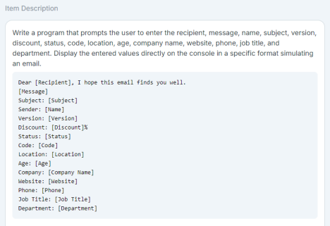
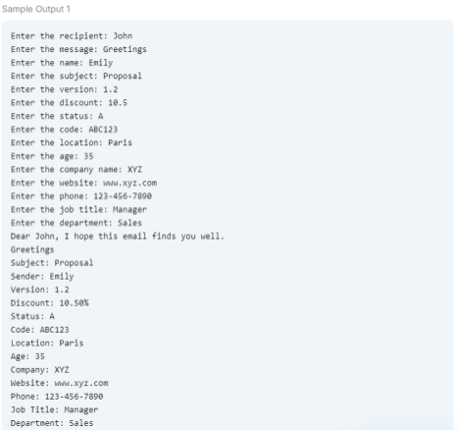Problem 4. Using Placeholders with % specifier
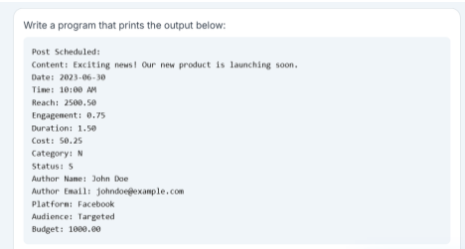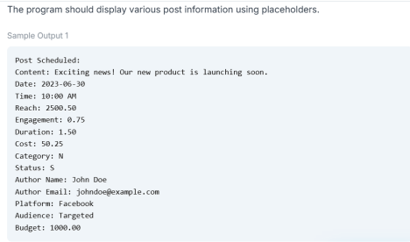
Problem 5. Type Casting
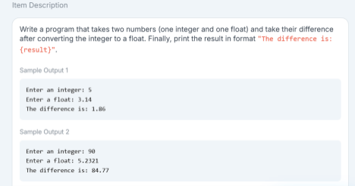-end-
Problem 1. Using print statement
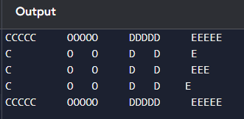
Problem 1. input
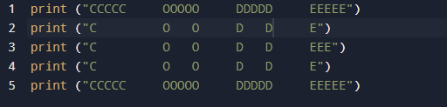
Problem 2. output
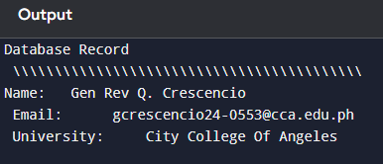

Problem 2. input
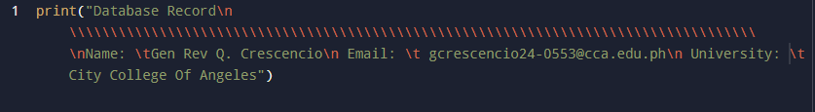

Problem 3. input